**FIT3175: Usability**

**(Stage A) - Data Gathering And User Analysis Report**

**Group 4**

**Ansley Tou Ka Chun: 30721598**

**Caleb Tan En Hong: 32579004**

**Lee Zhen Xuan: 31860532**

**Ong Kai Yun: 31861369**

# Table of Contents

# 

**Table of Contents 2**

**Group Report 3**

**Introduction 3**

**Rationale about our Chosen Target Group 4**

**Insights to our Questionnaire 5**

Question Structure 5

Question Topics 5

Questionnaire Dissemination 6

Reflection on Questionnaire 6

Analysis of Questionnaire Result 7

Beginner Hikers 7

Helpful Hiking App Features 7

Community Hikers 7

Hiking Photography 8

Graphs and Figures 9

**Conclusion 17**

**Appendix: Group Task 17**

Group Member 17

Task Allocation Form for Group Task 17

Questionnaire Form 18

Google Form 18

Results & Analysis 18

**Individual Tasks 19**

Member: Ansley Tou Ka Chun (30721598) 19

Member: Caleb Tan En Hong (32579004) 23

Member: Lee Zhen Xuan (31860532) 27

Member: Ong Kai Yun (31861369) 31

**Appendix: Individual Tasks 35**

User Persona Templates 35

Template 1 35

Template 2 35

User Stories Technique 35

# 

# 

# 

# 

# 

# 

# 

# Group Report

# Introduction

Our primary goal of developing a mobile hiking application is to assist individuals in tracking their hiking experiences. To accomplish this goal, we have devised a questionnaire to assist us in determining the demographic profile that our hiking application can effectively serve. The questionnaire is structured to gather essential information required to categorise potential users into specific groups. By collecting the responses from different demographics, we can obtain valuable insights from their hiking experiences to assist in designing our hiking app based on their needs and preferences. This could ensure that the app meets their expectations and provides maximum value to them.

After analysing the questionnaire responses, our group has compiled a reflective group report highlighting the emerging patterns observed across all the data collected. The report outlines key points that highlight the preferences and behaviours of the respondents, enabling us to tailor the application's features to meet their needs effectively.

After conducting a group analysis of the questionnaire data, each of us has individually created two user personas with different demographics to visualise their needs and preferences. We then utilised these personas to generate user stories that helped us to identify users’ pain points and their ultimate goals. Based on this analysis, we individually created two additional requirements that we think can further enhance the effectiveness of our app and improve user experience. Lastly, we came up with an analysis based on our personas, user stories and requirements that we have created. Indeed, this analysis could provide us with valuable insights that can effectively guide the development of our hiking app.

# Rationale about our Chosen Target Group

Our team is tasked to create a prototype of a mobile hiking trail application which will be designed based on the needs of our chosen target user groups. As a baseline, our target user group will be casual hikers, who live in Malaysia, ranging from young adults (18 - 25 years old) to adult age (26 - 35 years old). Among these groups, we can split them into four main categories of people which we want to gain insight from for the development of our application. Responses from these four target groups will be used to gauge the priority level of our different application requirements and features.

1. People who are inexperienced or are beginners at hiking. They typically have sparse knowledge on how to plan and carry out a hike. Hence, they will be more likely to depend on an online source, such as our hiking application to gather information regarding a hike. So, their concerns can be a great indicator for our application features.
2. People who are social hikers. They typically have more experience than the first category and usually hike with their social circles and community groups. Therefore, they are more likely to know what they would need during a hike and are able to recommend features that could improve their hiking experience with their community.
3. People who are interested or are actively participating in hiking photography. They usually have a mission to take photos or videos during their hiking expeditions. These photos can range from casual smartphone photography to professional hiking photography. Hence, we will be able to gauge the needs and interests of photographers to understand photography features we could add in our application.
4. People who have an active engagement on social media platforms. They usually have a high interest in sharing photos and experiences online and like to use social media platforms to interact with other people. With this group, we will be able to gather information on their expectations of community features in an application.

# Insights to our Questionnaire

## Question Structure

Our questionnaire consists of a total of 40 questions, subdivided into 4 sections, which are 12 demographic questions,15 hiking related questions, 9 photography questions and 4 general app questions.

The questionnaire includes a variety of question types tailored to the specific nature of each question. For general information or questions with specific, limited answers, we have used closed-ended questions. This includes the questions that come as a multiple choice question, or a checkbox question. The multiple choice question allows the respondents to only select one answer, which mainly concludes general information, as well as binary questions. For the checkbox questions, the respondents can select more than 1 answer, where it provides us more details based on their preferences and activities. Additionally, we have included questions that utilise rating scales. These scales make it easy for respondents to understand and complete the questionnaire efficiently, while also enabling swift analysis of responses. Throughout our analysis, a positive score of 3 or above out of 5 will be considered as a positive response from our respondents.

The overall structure of our questionnaire consists of only closed-ended questions mainly to allow the responses to be more consistent, save more hassle for the respondents, and simplify the analysis process. By filtering responses based on these answers, the analysis process would become faster and more straightforward. However, for some closed-ended questions, we have allowed respondents to select an “other” option to type in their own responses. This is because respondents may have unique perspectives or experiences that are best captured through their own words and best suit their situation that we may not have provided as an option. This provides us with richer qualitative data and deeper insights to our user groups’ perspectives.

## Question Topics

Questions of different topics were created to focus on our target user groups and to cater to their preferences in what they would like to see in a hiking app. These topics are based on our four main sections seen in our questionnaire.

Firstly, 12 basic demographics were asked. We have collected the respondents’ basic information, such as age, gender and living region. This information helps us to create different user profiles that can be used to understand the potential demographics of the hiking app which can help further improve the user experience for the majority of potential users. Additionally,15 basic hiking related questions were also brought up in the questionnaire to understand the behaviour of the potential users to cater to their hiking preferences, help them further understand the basic hiking information, and to assist them in any obstacles or difficulties they may face during their hiking journey.

Furthermore, since one of our target requirements are photography related features, 9 basic photography-related questions were also brought up in our questionnaire. We took into account that some hikers tend to take photos during their hiking journey, where some may even use professional photography equipment. Therefore, these questions can help us understand what features they are looking for in a hiking app with photography-related features. Moreover, these questions can also help us improve our hiking app with new features that the users might be looking for if these features were not included initially but deemed important. Lastly, 4 general app features questions were also included in our questionnaire. These questions can help us understand what a user is looking for in an application’s general features which can motivate users to continue using an app, or to attract new users into trying out an app.

Overall, the questionnaire is designed to gather comprehensive information from our target groups which will help us improve our hiking app, as well as allowing us to cater to the needs and understand the preferences of our target user group.

## Questionnaire Dissemination

A Google form questionnaire was created since it is the most easily accessible and widespread type of questionnaire form. The link to the form was disseminated by each of our group members, with an expected minimum number of 10 respondents each. To maximise the reach, our questionnaire was disseminated by social media, mainly by creating posts containing the link to the questionnaire, and posting it through Instagram stories. Besides that, our link was also distributed through Whatsapp group chats including family, clubs and societies, and other course units’ group chats in order to gain more responses. To further widen our reach, the link to our questionnaire is also distributed personally to families and friends.

## Reflection on Questionnaire

There are several parts of the questionnaire that can be improved on. First of all are the questions which are related could have a problem in lack of conditional logic in the question branching process. For example, one of the questions asks whether the respondent hikes, and it is followed by some questions that have made the assumption that the respondent does indeed hike without taking into account or giving the option that the respondent might not hike at all. Therefore, this can lead to confusion and frustration for the respondent when they are dealing with the questionnaire, and also causing difficulties in the analysis process.

Besides that, another problem regarding our questionnaire is too many neutral options in the questions. These neutral options can pose difficulties in the analysis process as missing data, or incomplete information where not much analysis can be concluded from these responses.

## 

## Analysis of Questionnaire Result

### Beginner Hikers

Based on the responses from our questionnaire, the majority of the respondents are students between 18 to 25 years old. We can observe that most of the respondents in this majority do not hike frequently. From our analysis, 46% of the respondents do not hike, 42% of the respondents hike a few times a year, and about 11% of the respondents hike weekly or a few times a month. This suggests that a significant portion of this majority group do not hike at all or hike less frequently, while a smaller portion participate in the activity on a more regular basis.

For those who hike, most of them gave a positive response on needing to know the importance of the trail difficulties, trail location and trail distance (Figure 1). On the other hand, the importance of trail amenities and reviews are scored averagely. Hence, this shows that most of them consider the trail difficulty level, locations and distances are more important than the trail amenities and reviews. This may be because most of our respondents are novice hikers, so the difficulty level can help them determine if it suits their fitness level and skill set. They might also want to choose a trail that is close to home or easily accessible, as they don't have to spend a lot of time travelling to the trailhead. The trail distance also seems to be important as they may not want to challenge themselves on a long trail due to their lower endurance level and lack of experience. Therefore, a hiking app that allows the user to choose their trail based on their required trail difficulty and distance would be a great option to cater to their hiking needs.

### Helpful Hiking App Features

Our survey results demonstrate that the majority of respondents find hiking trail apps useful, with only five out of 112 disagreeing (Figure 2). The top 3 limitations of such apps are outdated information, lack of detailed maps, and limited community engagement (Figure 3). Using these findings, we plan to develop an app that addresses these key limitations, while also including emergency services, as identified as a necessary feature by our analysis (Figure 4). We also learned that most users prefer online maps over topographic maps, which we will include as an option in our app (Figure 5, Figure 6). Additionally, our analysis of the trade-off between GPS tracking and trail history preservation revealed that most users who want to save their hiking trails are comfortable with GPS tracking (Figure 7). As a result, we will implement a feature to save users' hiking trails using GPS, which will provide greater accuracy.

### Community Hikers

According to our observations, the majority of the respondents are mostly engaging towards community features. However, this contradicts the fact that the majority of the respondents do not share their hiking photos specifically on social media (Figure 8). This may be because most of the respondents do not think that the usual social media apps are a suitable platform to share their hiking photos. A platform that is specifically made for sharing their hiking photos to others with a similar interest in hiking will act as a more suitable sharing platform. Besides that, about 72% of the respondents who are more engaging towards social media are more willing to interact with other hikers and photographers (Figure 9). This might be because they are more social in general, and therefore more likely to seek out social interaction towards other hikers and photographers given a platform with community features to reach out to others with similar interests. Also, about 88% of our respondents are within the age group of 18-25 years old. This correlates to the fact that most of our respondents are young adults who are students. Furthermore, 73% of these respondents are more interested in seeing a user profile customization feature in the hiking app (Figure 10). This may be because users may like to express themselves using user profile customization features. Around 77% of our respondents who are within the majority age group are also more likely to be interested in a reward system within the hiking app which grants users points after completing a certain task (Figure 11), while the overall responses towards the gameplay aspects were uniformly distributed. However, around 76% of the respondents are still interested in seeing some gameplay aspects in the app (Figure 12). This may be because these young respondents are familiar with reward systems from other apps and have interest in gamification features. Additionally, most of the respondents were not interested in a one-time payment to unlock app features (Figure 13). This may be because the majority of our respondents are students and do not have the financial ability to have in-app purchases unless they think it is necessary.

### Hiking Photography

For our respondents’ photography skills, we found that 50% of our respondents gave their photography skills a score of 3, while the scores lesser and greater than 3 were split into a total of 25% each (Figure 14). Furthermore, around 98% of our respondents said that they use smartphones for their photography, with the rest of respondents saying that they use professional cameras or do not partake in photography activities (Figure 15). From this analysis, we can conclude that most of our respondents are amateur photographers who usually take pictures using smartphones, with only a small minority being experienced with professional photography. Relating to our target age group, this is a sensible conclusion as most students won’t be experienced with professional photography unless it was their hobby or profession. Additionally, some may not be able to afford expensive equipment and rely on their smartphones for photography.

For the analysis of the photography app features, we will mostly look into the respondents with a positive score for photography skills since they are our target audience for this. Out of a total of 80 respondents included in this group, 67 responded with a positive score when asked if they would stop and take photos while on a hike (Figure 17). Therefore, the target group is suitable for our photography features as there is a positive relationship between the respondent’s photography skills and the frequency of taking photos on a hike. When asked if the respondents were interested in hiking photography tips and tutorials and photo spot recommendations, 64 and 77 responded with a positive score respectively (Figure 16, Figure 18). Surprisingly, the respondents who had low photography skills responded favourably on the best photo spot recommendations, with 22 out of 32 responding with a positive score (Figure 18). Hence, we can conclude that the respondents with interest in photography are more keen to improve on their skills with the tips and tutorials. In comparison, all respondents in general are very keen on knowing the best photo spot locations. This may be because they still want to enjoy the nice views of nature despite lacking in photography skills or needing the help of others to take photos of themselves. Therefore, a hiking app that provides user tips and tutorials on hiking photography as well as recommending great photo spot locations will help cater to the needs of users especially hiking photographers.

### Graphs and Figures

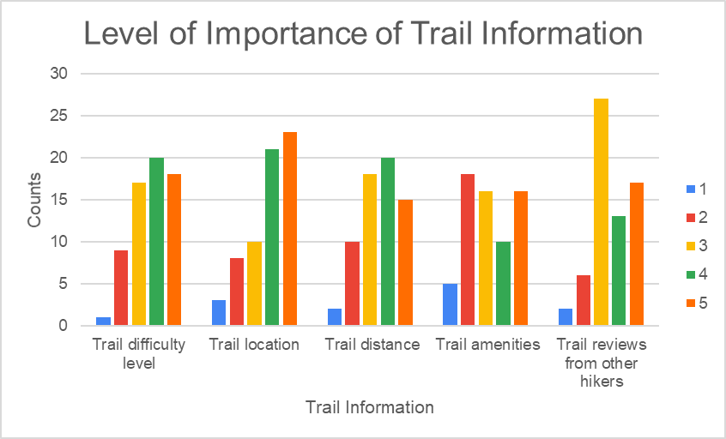

Figure 1: Level of importance of trail information

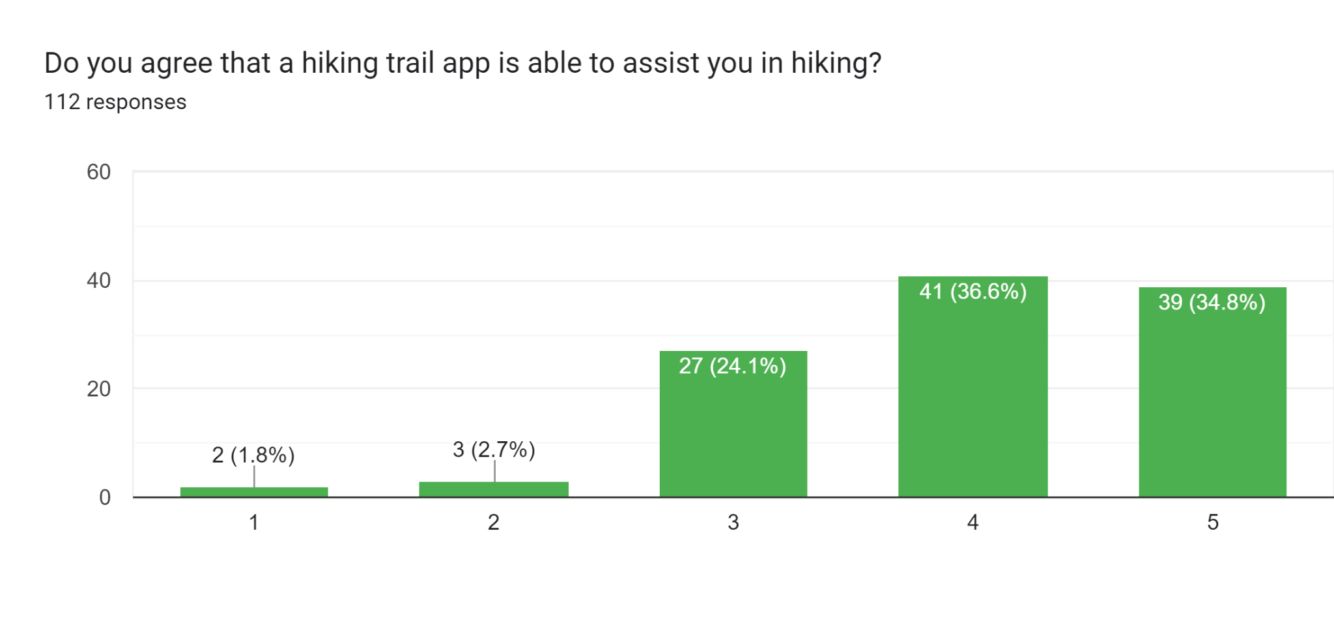

Figure 2: Importance on hiking trail app by scale

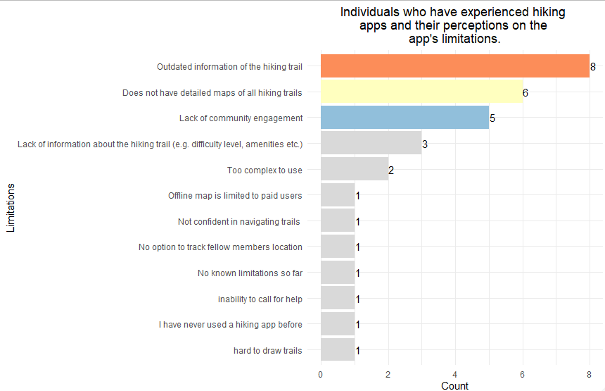

Figure 3: Limitations of those who has experience with hiking apps

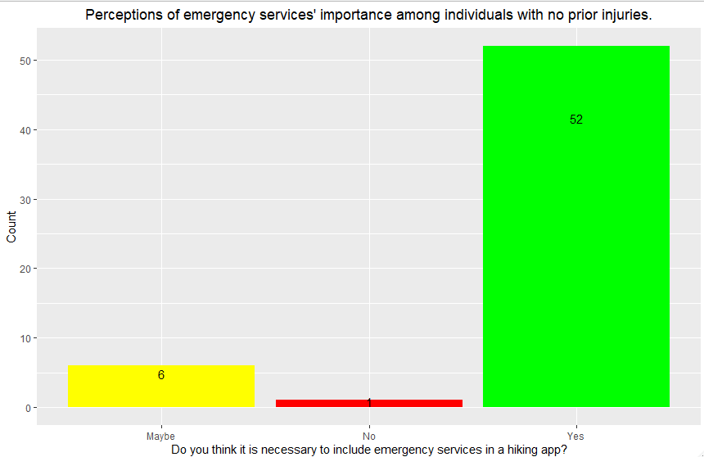

Figure 4: Perceptions of emergency services’ importance among individuals with no prior experience.

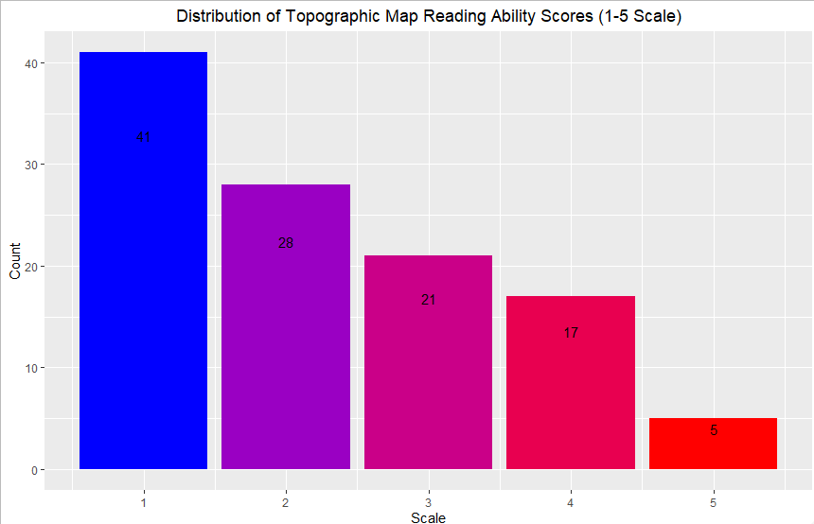

Figure 5: Distribution of Topographic Map Reading Ability Scores (1-5 Scale)

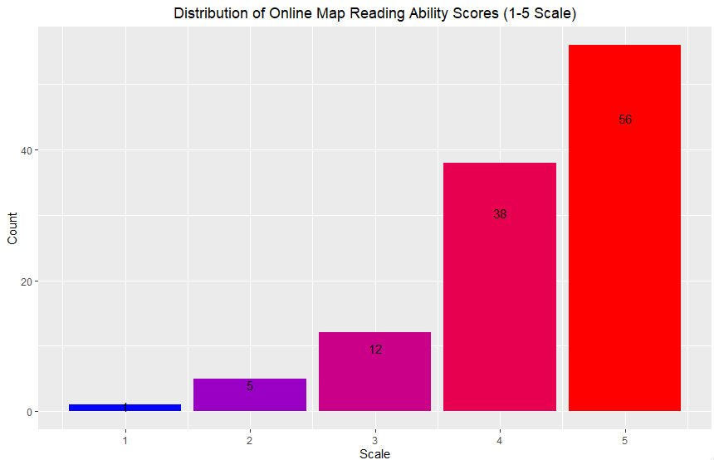

Figure 6: Distribution of Online Map Reading Ability Scores (1-5 Scale)

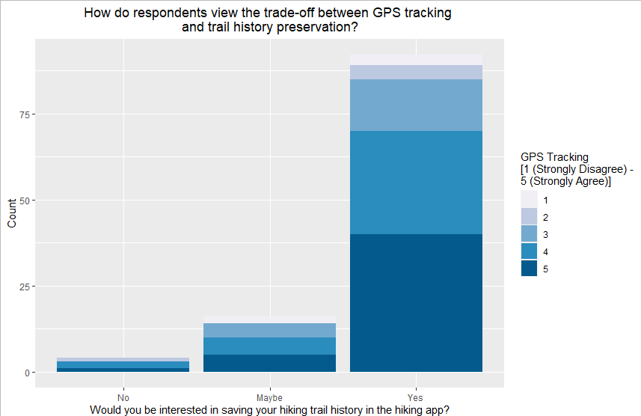

Figure 7: Trade-off between GPS tracing and trail history preservation

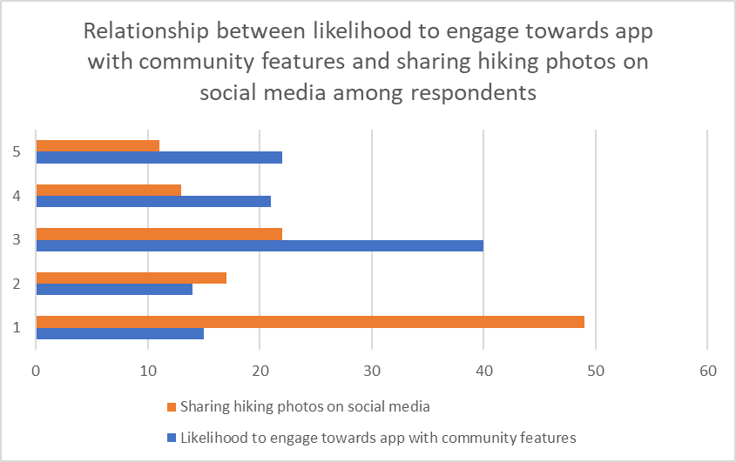

Figure 8: Likelihood to engage towards app with community features and sharing hiking photos on social media among all respondents

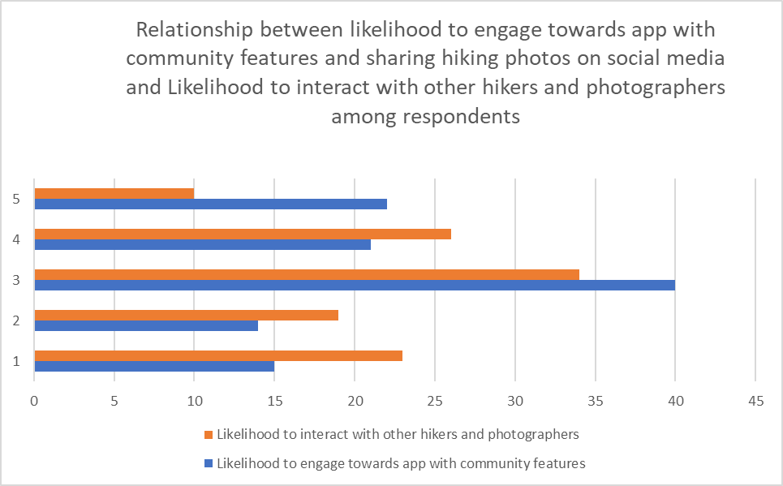

Figure 9: Likelihood between engaging towards app with community features and sharing hiking photos on social media and likelihood to interact with other hikers and photographers among all respondents

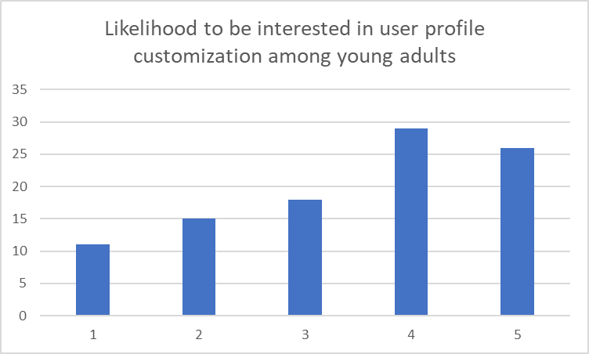

Figure 10: Likelihood to be interested in user profile customizations among young adults (18-25 years old)

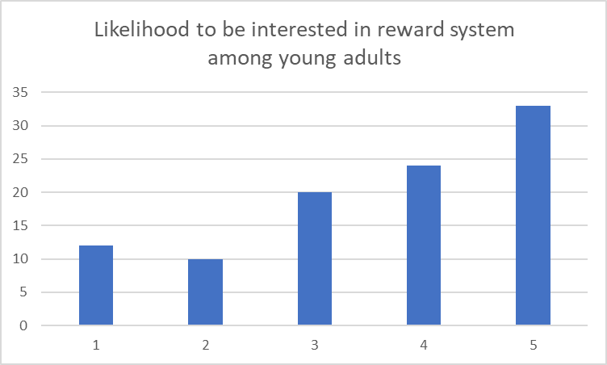

Figure 11: Likelihood to be interested in reward system among young adults (18-25 years old)

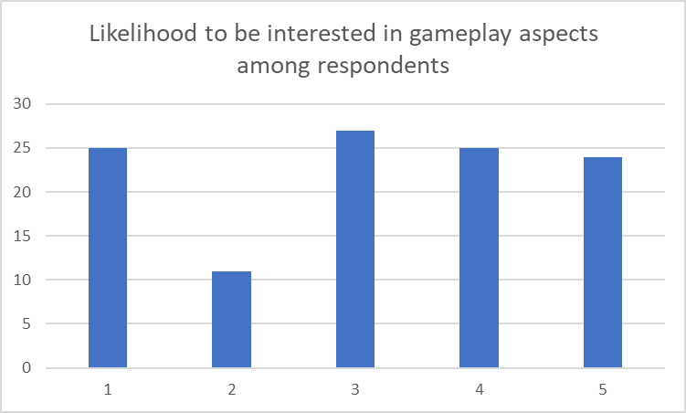

Figure 12: Likelihood to be interested in gameplay aspects among all respondents

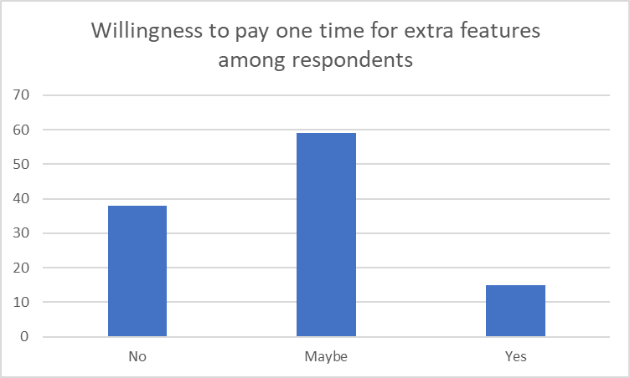

Figure 13: Willingness to pay one time for extra features among all respondents

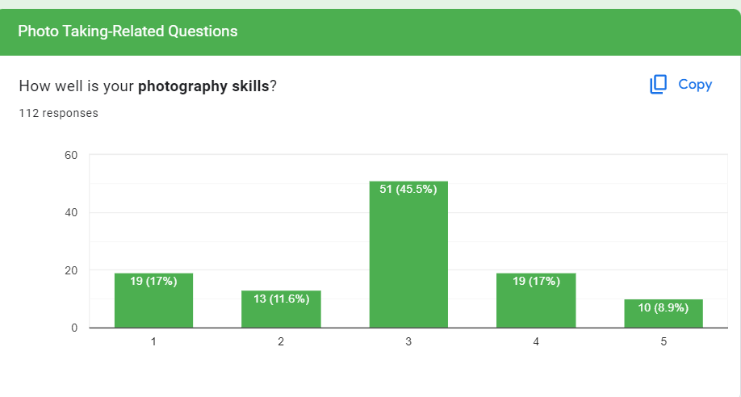

Figure 14: Photography skills of respondents

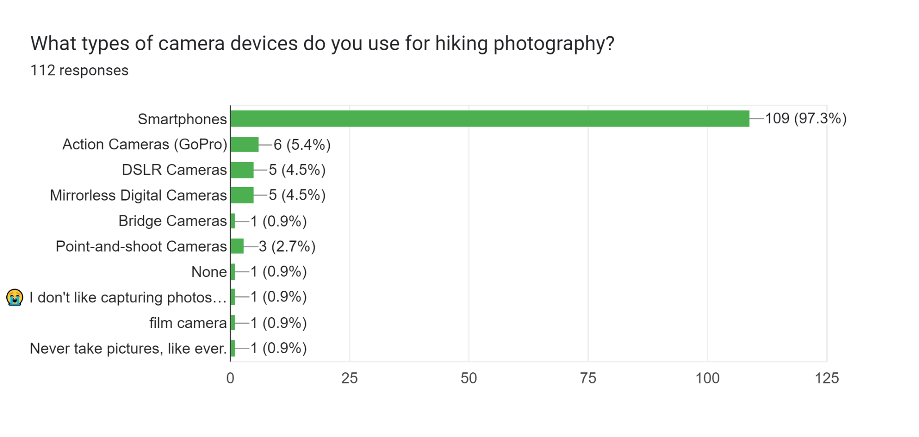

Figure 15: Types of camera devices used for hiking photography

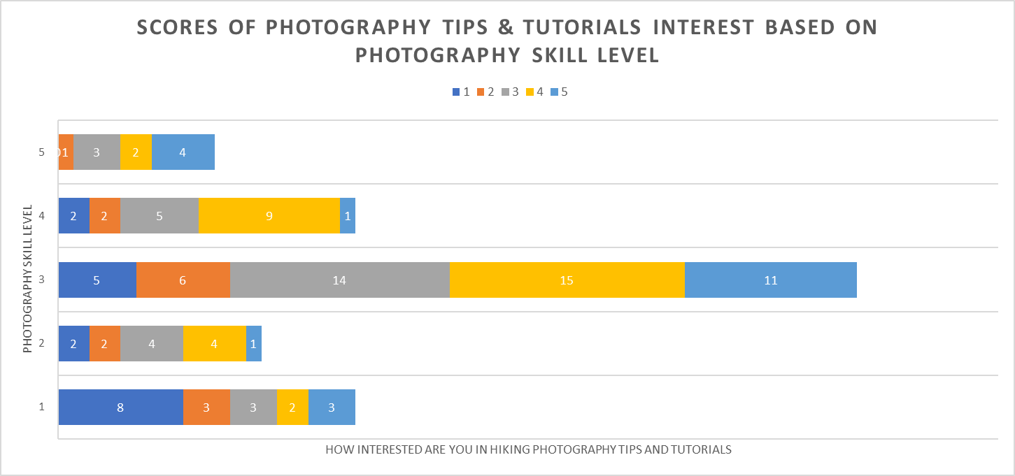

Figure 16: Scores of photography tips and tutorials interest based on photography skill level

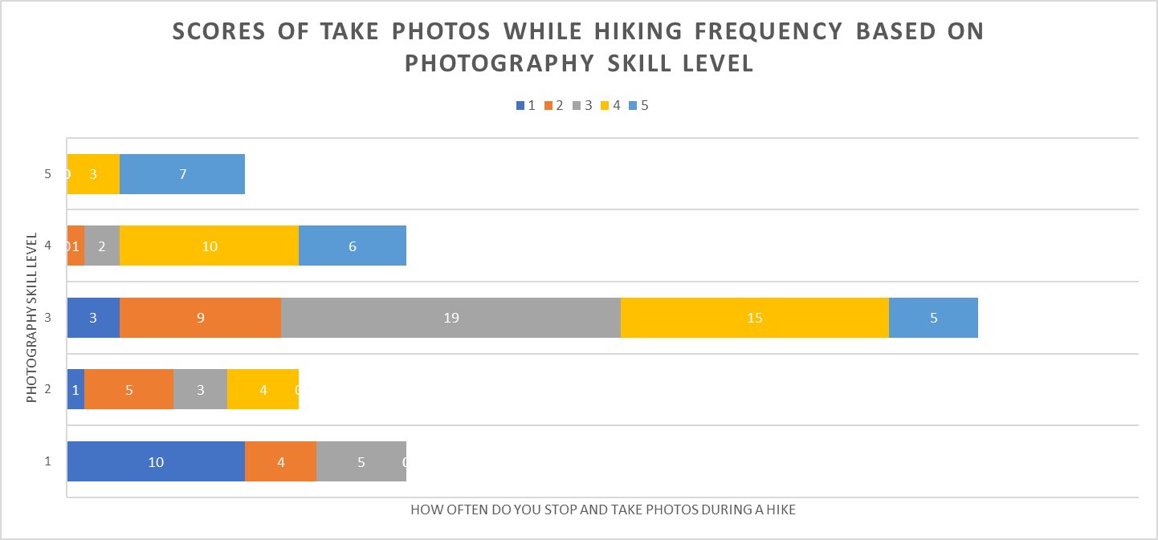

Figure 17: Scores of taking photos while hiking frequency based on photography skill level

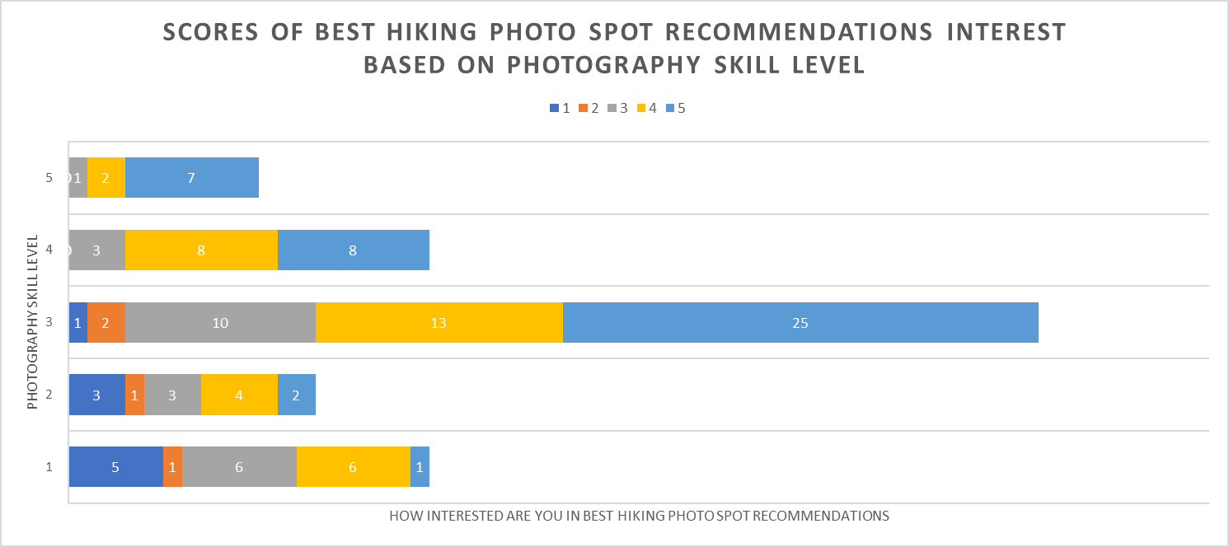

Figure 18: Scores of best hiking photo spot recommendations interest based on photography skill level

# Conclusion

Through the survey we conducted, we were able to understand the diverse needs and preferences of our users when it comes to hiking. We realised that people's motivations and goals for hiking vary greatly, depending on factors such as age, employment status and challenges they faced while planning a hike. By taking into account these different factors, we were able to design a hiking app that caters to a wide range of users, providing them with personalised recommendations, safety features, and social networking opportunities. Our aim is to provide a comprehensive and enjoyable hiking experience for everyone, regardless of their background or experience level.

# Appendix: Group Task

## **Group Member**

| **Name** | **Student ID** | **Monash Email** |
| --- | --- | --- |
| Ansley Tou Ka Chun | 30721598 | atou0004@student.monash.edu |
| Caleb Tan En Hong | 32579004 | etan0062@student.monash.edu |
| Lee Zhen Xuan | 31860532 | zlee0044@student.monash.edu |
| Ong Kai Yun | 31861369 | kong0014@student.monash.edu |

## Task Allocation Form for Group Task

[Task Allocation Form](https://docs.google.com/document/d/1Jb7W8CxitVi7uFJNbmEBg8oo2dhoyXvG/edit?usp=share_link&ouid=105847352174600454490&rtpof=true&sd=true)

| **Tasks** | **Team member(s) allocated to complete the task** | **Team member(s) who actually completed the task** |
| --- | --- | --- |
| Introduction | Ong Kai Yun | Ong Kai Yun |
| Questionnaire  (Mention how many questions each Team Member was required to provided) | Ansley Tou Ka Chun - 10  Caleb Tan En Hong - 10  Lee Zhen Xuan - 10  Ong Kai Yun - 10 | Ansley Tou Ka Chun - 10  Caleb Tan En Hong - 10  Lee Zhen Xuan - 10  Ong Kai Yun - 10 |
| Responses  (Mention how many each Team Member collected) | Ansley Tou Ka Chun - 28  Caleb Tan En Hong - 28  Lee Zhen Xuan - 28  Ong Kai Yun - 28 | Ansley Tou Ka Chun - 28  Caleb Tan En Hong - 28  Lee Zhen Xuan - 28  Ong Kai Yun - 28 |
| Rationale | Ansley Tou Ka Chun  Caleb Tan En Hong  Lee Zhen Xuan  Ong Kai Yun | Ansley Tou Ka Chun  Caleb Tan En Hong  Lee Zhen Xuan  Ong Kai Yun |
| Insights of Questionnaire | Caleb Tan En Hong  Lee Zhen Xuan | Caleb Tan En Hong  Lee Zhen Xuan |
| Analysis of Questionnaire | Ansley Tou Ka Chun  Caleb Tan En Hong  Lee Zhen Xuan  Ong Kai Yun | Ansley Tou Ka Chun  Caleb Tan En Hong  Lee Zhen Xuan  Ong Kai Yun |
| Conclusion | Ong Kai Yun | Ong Kai Yun |

## 

## Questionnaire Form

The questionnaire Google form and results can be referred to in the links below:

### Google Form

[Hiking Trail App Questionnaire](https://docs.google.com/forms/d/1m93ynQI8ZRpCdkpfHhNdGetbExZHQGPE6u95-FDkME0/edit) (Edit Mode)

## Results & Analysis

[Hiking Trail App Questionnaire (Responses)](https://docs.google.com/spreadsheets/d/1o1eQl-9Y-ZiPKWCBD4g1GEqXMtwaA39JYLsqPJ84hWw/edit?resourcekey#gid=1133093212)

# Individual Tasks

## Member: Ansley Tou Ka Chun (30721598)

**User Personas**

## 

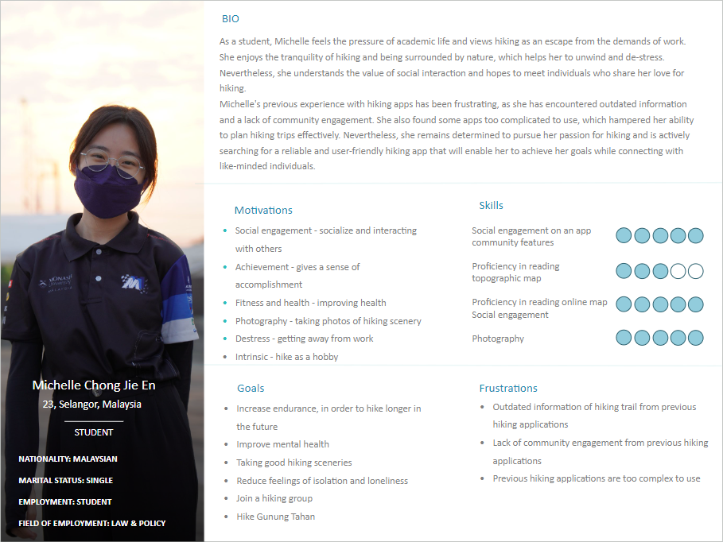

**User Stories**

| Priority | User Stories | Justification |
| --- | --- | --- |
| Must Have | * As Robert, I want to be able to search and discover hiking trails, so that I can trail that suits my needs      * As Robert, I want to look at maps, so that I can navigate through the a hiking trail * As Michelle, I want to be able to chat with other users, so that I can have some social interactions * As Michelle, I want to be able to monitor my hiking performance, so that I know what’s my hiking progress | Users' preferences and needs for hiking vary, including difficulty level, terrain, distance, and location. A search and discovery feature can personalise the app for users like Robert, allowing him to find trails that meet his criteria.  A map feature can enhance safety and enjoyment by helping users navigate and discover new routes.  Social interaction, through a chat feature, can foster connections and a sense of community, increasing engagement.  Tracking hiking performance metrics, such as distance, time, and elevation, can provide motivation and a sense of achievement for users like Michelle, improving the app's effectiveness.  Adding these features is necessary because they fulfil the basic needs of a hiking trail app. For hikers like Robert and Michelle, the search and discovery feature, map, chat function, and performance tracking are essential components for a personalised and safe hiking experience. |
| Should Have | * As Michelle, I want to be able to look for hiking groups, so that I can join a hiking group | Socialising is crucial for hikers like Michelle. A group feature would enable her to connect with other hikers, exchange tips, and make friends with common interests, increasing the app's engagement and value. |
| Could Have |  |  |
| Won’t Have |  |  |

**Additional Requirements**

**Allows users to plan hikes with other users**

The hiking trail app feature that enables users to organise hiking trips with other users considers critical factors such as trail difficulty, weather, and timing when selecting the route and setting the date and time. Tools such as sharing trail information and setting meeting points are available to simplify coordination between users, promoting a collaborative hiking experience that encourages social interaction and group formation. Users can invite others to join them on a hike through the app, and Google Calendar invitations can be sent to ensure everyone is on the same page regarding the hike details. These features make it simple and convenient for hiking enthusiasts to plan and coordinate hikes with others using the app.

**Allows users to communicate with other users**

A feature in a hiking trail app that enables users to interact and communicate with each other. This feature can consist of a messaging system, chat function, or forum where users can exchange information and tips about hiking, discuss related topics, and plan hiking trips. Through this communication feature, users can form connections, explore new hiking trails, and arrange group activities or hikes.

**Individual Analysis/Reflection**

I have developed two user personas named Robert and Michelle, derived from the information we gathered from the identified persona groups. These personas help us understand the target audience for the hiking trail app, their goals and behaviours when using such apps, and provide valuable user perspectives. By utilising these insights, my team can gain a competitive advantage and position the app ahead of its competition.

The two user personas, Robert and Michelle, are based on the "Community hikers" persona group, which comprises casual and experienced hikers who enjoy sharing their hiking experience with others. This group prefers to hike with family and friends as they are motivated to hike to socialise and interact with others. By understanding the needs and behaviours of this persona group, our team can create a hiking trail app that caters to their preferences, providing a competitive edge in the market.

Robert is a 27-year-old Malaysian male and full-time employee who enjoys hiking as a way to improve his physical and mental health and escape from the demands of work and city life. He values social interaction and hopes to connect with like-minded individuals through hiking. These observations are based on the responses of four Chinese Malaysian workers who also prefer to hike with family and friends. Robert represents a larger group of individuals who are motivated to hike for their health benefits. Among these respondents, 50% have encountered limitations with previous hiking apps due to outdated information on hiking trails. Like others in this group, Robert hopes to have a reliable and updated hiking app to help him plan his trips and achieve his goals. Therefore, it would be beneficial for our app to include a feature that allows users to plan hiking trips and connect with other like-minded individuals.

Michelle is a 23-year-old Chinese female student who considers hiking as an escape from academic pressure and a way to destress. She represents 7% of the respondents who are female students and want to improve their health. Michelle enjoys the tranquillity of hiking, but she also hopes to connect with like-minded individuals. In fact, within the 7% of respondents who are female students, a significant number are motivated to hike for social interaction, a motivation shared by 22% of all respondents. Unfortunately, Michelle has had frustrating experiences with previous hiking apps, which lacked updated information and community engagement. She is looking for a reliable and user-friendly app that will help her plan hiking trips effectively and connect with other like-minded individuals. Therefore, implementing a feature that allows individuals like Michelle to communicate with others who share her passion for hiking is essential.

## 

## Member: Caleb Tan En Hong (32579004)

**User Personas**

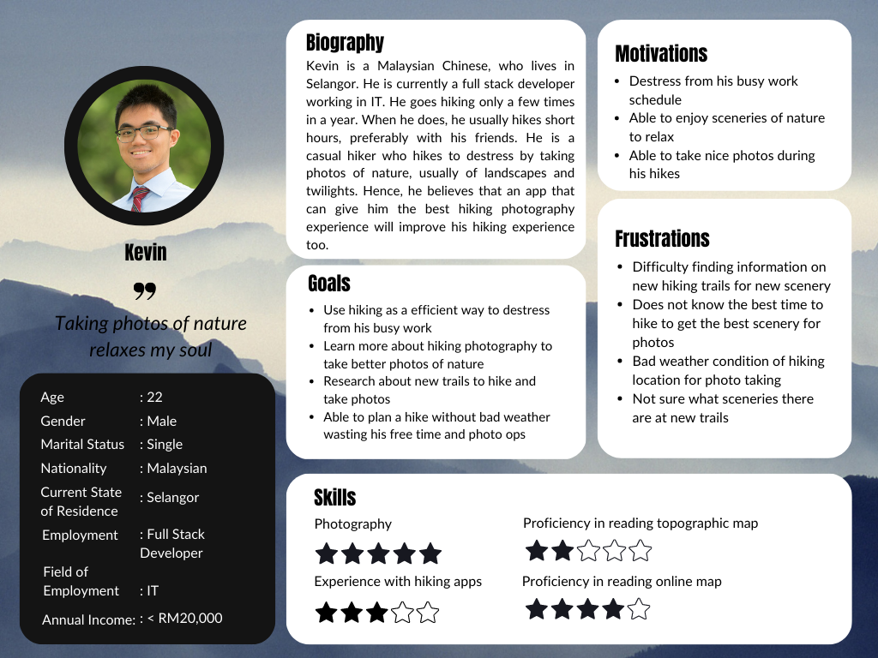

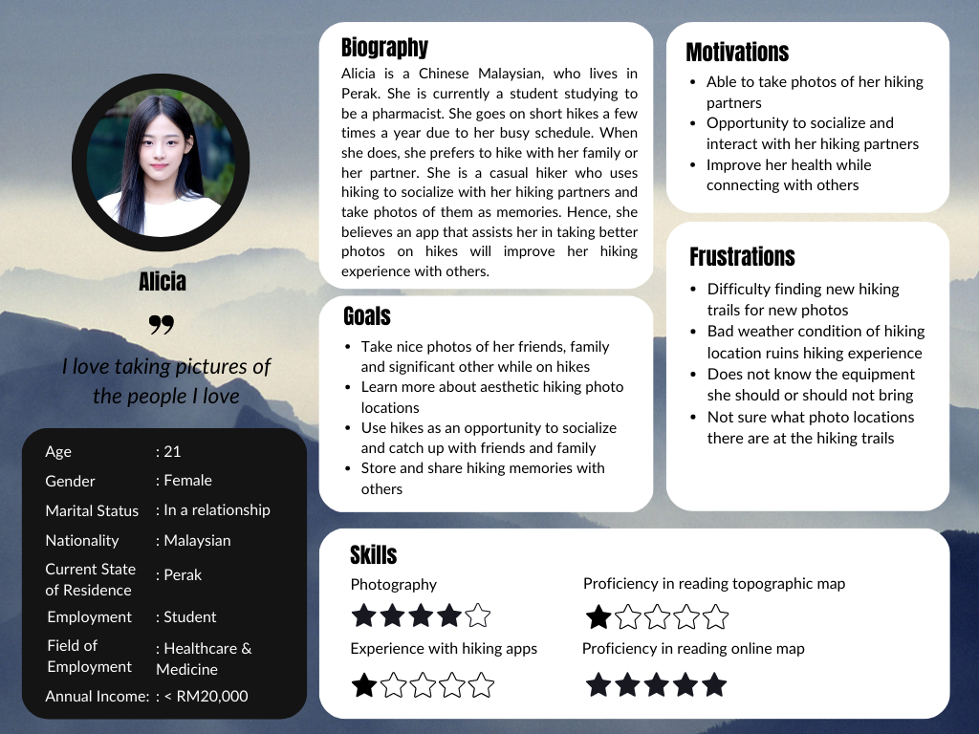

**User Stories**

| Priority | User Stories | Justification |
| --- | --- | --- |
| Must Have | * As Kevin, I want to be able to easily find new hiking trails, so that I can have new trails to hike and destress. * As Kevin, I want to know about the weather condition of the hiking trail, so that it won't ruin my photo ops. * As Kevin, I want to be able to know the best time for hiking photography, so that I can capture the best scenery photos * As Alicia, I want to know the best photo locations at each trail, so that I can take nice photos of my hiking partners. | Our hiking app’s main focus is to accurately provide hiking trail information to our users so that they have the best hiking photography experience. Information listed in these user stories, such as hiking trail locations, weather conditions and best duration to hike, are essential information for our users in order for them to successfully plan a hike for pictures. Hence, we must implement features to display this information to our users.  Our hiking app also has a side objective of potentially providing suitable hiking photography information for our users to have the best hiking photography experience on their hiking journey. Hence, providing information on the best photo locations and scenery locations during a hike through already existing pictures can help improve their experience. |
| Should Have | * As Alicia, I want to know the suitable photo equipment to bring during a hike, so that I won't have trouble carrying it around. | Knowing what equipment to bring can also be significant when planning a hike on steep or wet terrain. Better equipment can also be recommended depending on the possible photo ops. However, since this information is quite subjective, it is more difficult to provide accurate information on it. |
| Could Have |  |  |
| Won’t Have |  |  |

**Additional Requirements**

**A feature that displays best photo-taking locations on a hike**

This feature would be for people who are interested in taking pictures during a hike. Based on our analysis, the majority of people were greatly interested in a feature that could recommend the best photo taking spots on hiking trails. Kevin and Alicia would both benefit from a feature like this as well since unique types of photos, such as Kevin’s scenery and Alicia’s social photos can be taken at different scenic locations. The feature on the app could be embedded onto the map, showing images of the scenic locations on the hike or it could be displayed for users to look through in list form. Users would be able to have a reference of the photo-taking location, which can help them greatly in planning their hiking photography journey. Furthermore, we can also categorise the locations into different views such as landscape, waterfall, flora and many more.

**A feature that displays tip and tutorials for hiking photography**

This feature would be for people who are interested in learning about hiking photography and want to improve their hiking photography skills. Based on our analysis, the majority of people are interested in having a feature that could provide hiking photography tips and tutorials. Kevin and Alicia also benefit from this feature as it will help them improve the quality of the photos taken. The feature on the app could provide recommendations on photo angles, perspectives and lighting in different locations and weather conditions. For Kevin, the feature could also give users the best time of the day to capture photos, such as sunrise and sunset, so that users can plan their hikes accordingly. For Alicia, the feature could show example photos for her to reference poses and shots. Additional tips and tutorials can be added after further development.

**Individual Analysis/Reflection**

My 2 user personas, Kevin and Alicia were created based on the analysis and overall result from our questionnaire responses. Each persona was assigned some basic demographic information to help visualise their situation, along with a biography, goals, motivation and challenges regarding hiking activities. The rating stars are given based on an average of the scores for the listed skills from our questionnaire responses. Additionally, a quote is also given to summarise their goal in hiking.

The basic demographic information of the 2 personas is based on the majority results on the demographic related questions. Hence, both personas are created to be Malaysian Chinese in the 18 to 25 years old age range in order to capture the perspective given by our majority user group. My responsibility in this assignment was to focus more on the people who are interested or participate in hiking photography, either casual or experienced. Therefore, I also created the personas based on the user group that responded with favourable scores regarding their photography skills, which is a score of 3, 4 or 5 for all photography-related design decisions. The usability-focused information is mostly based on the photography-related usability questions, with small references to the hiking related questions.

For Kevin, I created him to be a developer working in IT and living in Selangor. Kevin was created to be a person that was interested in hiking photography, while I created Alicia to be a student studying to be a pharmacist and living in Perak. Both have an interest in hiking photography and usually go on short hikes. However, their motivations differ where Kevin hikes to take scenic photos which helps him to destress, while Alicia hikes to catch up with her relationships by socialising during the hike and taking good pictures of the people she loves, like her family, friends and significant others. Additionally, Kevin prefers to take pictures of landscapes and twilights, while Alicia likes to take social pictures in general, like pictures of herself, others and her hiking experience. For Kevin and Alicia, all their demographic information and motivations are created based on the majority information on their respective genders from the questionnaire.

With these 2 personas, I was able to have deeper insights regarding the motivations and frustrations of our users associated with their goals. Therefore, we can effectively explain how and why they would engage with our app using user stories crafted based on the created personas. Now, the need to refer to the raw data decreases immensely, which helps me to focus on my targeted user group more easily. Then, photography-related app features can be suggested in my requirements which are decided and justified based on my user story priorities.

By analysing my user personas and the responses from the questionnaire, I was able to create 7 user stories from their motivations, goals and frustrations. These user stories mostly reflect their need and interest regarding hiking and photography because those topics are our app’s main targeted features. Since my target user group is the photography enthusiasts, my requirements are more related to photography features. The requirements I recommended aim to satisfy my persona’s needs by providing them a better hiking and hiking photography experience using the app.

## 

## Member: Lee Zhen Xuan (31860532)

**User Personas**

[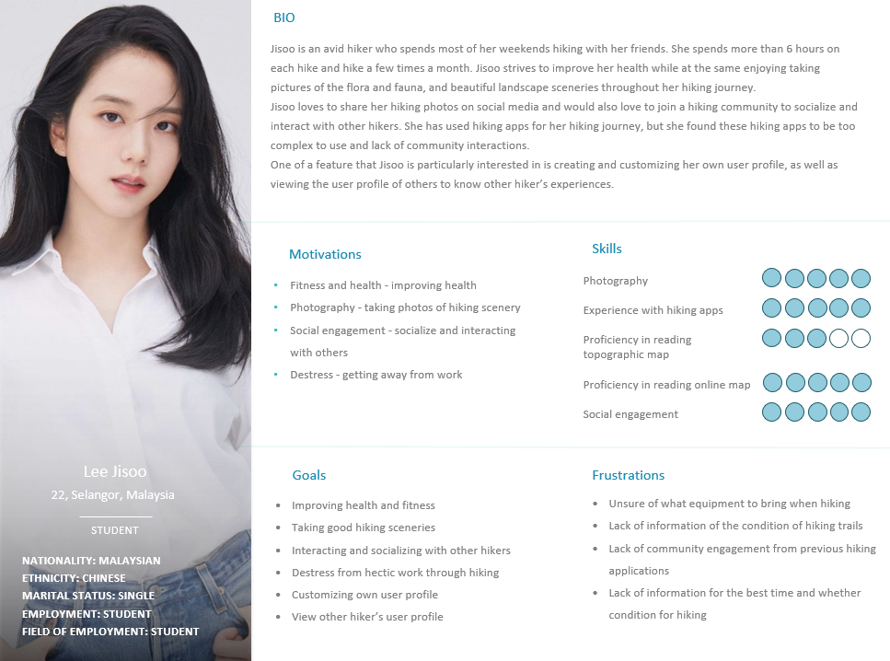](https://imgur.com/M6gpHDZ)

[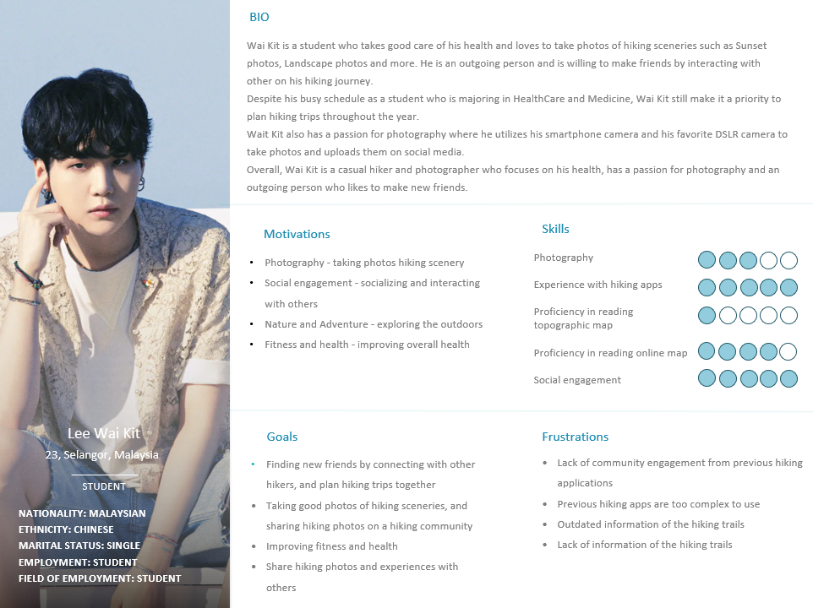](https://imgur.com/vshrXjE)

**User Stories**

| Priority | User Stories | Justification |
| --- | --- | --- |
| Must have | * As Wai Kit, I want to find updated informations about hiking trails so that I can plan my hiking journey accordingly | Information based on the condition of the trails should be added and updated regularly to allow the users to be well prepared for any unexpected outcomes or dangers. For example, if the hiking trail condition is wet or unstable, the users should be pre-informed so that users can prepare special equipments or even avoid these hiking trails |
| Should have | * As Jisoo, I want to be able to find hiking communities so that I can socialise and interact with others that like hiking too. | An implementation of a hiking community should be implemented to allow the users to be able to socialise and interact with others. The hiking community should be a more comfortable place for hikers to share their experiences or hiking photography with other hikers with similar interests as each other. |
| Could have | * As Wai Kit, I want to be able to add new friends in a hiking app so that I can plan hiking trips with them * As Jisoo, I want to be able to create a hiking user profile so that I can customise my user profile and express myself as well as viewing other people’s user profile * As Wai Kit, I want to be able to share my hiking photos in a community so that I can connect with other hikers and inspire other hikers. | A feature of adding new friends could be added in order to keep in contact with those that they have recently interacted with, or usually interact with for much convenience in planning new hiking trips as well as encouraging interaction between hikers.  A feature regarding creating a user profile could be added in order for users to save their hiking experiences as well as expressing themselves in terms of their recent hiking activity.  A community feature that allows the users to share their hiking photos would be a great way for users to express their passion in hiking as well as hiking activities. |
| Won’t have |  |  |

**Additional Requirements**

**Community feature to socialise with other hikers and photographers**

A community feature in the hiking app where users can socialise with other hikers and hikers who love photography could be implemented. This is because based on the collected responses, users who have used a hiking app in the past have brought up a problem where the hiking app lacks community engagement to find hiking stories or information from others, and to socialise with others. From the collected data, about 62.5% of the respondents have also given a positive response to being interested in interacting with other hikers and photographers. Therefore, a hiking app that features a community function would be a great feature for the users to interact with other hikers and hikers who are interested in photography by creating new posts, threads or even sharing photos of their hiking experiences and journey.

**Include a user profile feature in the hiking app**

Based on the collected responses from our questionnaire, about 74% of the respondents are interested in having user profile customization options. These customizations would be a great way for users to share their hiking experiences by creating posts on their profile to share their hiking experience, adding a biography to introduce themselves to others as well as adding updates to their profile. This would be a great way for the users to express themselves based on their hiking experiences, as well as getting to know more about other hikers as well.

**Individual Analysis/Reflection**

After collecting the data based on the responses of the questionnaire, two user personas were created. These user personas were created based on analysing the responses collected to identify common patterns and trends that have occurred in the majority of respondents. The user stories derived from the user personas enables the developers to describe how the majority of the users might interact with the hiking app by considering the various needs and goals of the users. This approach helps ensure that the final product of the hiking app fulfils the needs of the target audience and provides a user experience that caters to the preferences of the users.

Jisoo is a 22 year old female student who was born and raised in Malaysia. She is an avid hiker who spends most of her weekends hiking with her friends, and she spends more than 6 hours on each hike, and hike a few times a month. Jisoo represents a group of hikers who strive to socialise and interact with other hikers. This is based on a group of respondents where about 36% of the respondents’ motivations in hiking is to socialise and interact with other hikers, and about 62.5% of the respondents gave a positive response into being interested in engaging with other hikers and photographers. Therefore a community feature could be implemented to allow the users to interact with other hikers and photographers with similar interests by sharing their hiking experiences as well as making new friends to plan hiking trips together. One of the main motivations of Jisoo is to create and customise her own user profile in order to express herself, share her hiking experiences on her profile as well as view other hikers’ profile to know more about their hiking experiences. This is inspired by the responses from the questionnaire where about 52% of the respondents gave a positive response to seeing a customisation feature in the hiking app. A user profile is a good way for users to get to know more about the personalities of other hikers as well as hiking experiences based on other hiker’s user profile, and therefore finding new friends that suits their personality as well.

Wai Kit is a 23 year old Chinese student who was also born and raised in Malaysia. He plans hiking trips throughout the year and takes good care of his health and loves to take photos of different hiking sceneries such as Sunset, Landscape photos and more. He is an outgoing person and is willing to make friends by interacting with others. Wai Kit’s biography was taken from the traits of the majority respondents where about 88% of the respondents fall in the age range of 18-25 years old, and about 89% of the respondents are Malaysian Chinese. One of Wai Kit’s goals and motivations in hiking is to utilise his smartphone camera and his favourite DSLR camera to take good photos of hiking sceneries throughout his hiking journey, and sharing them to a hiking community. This trait has been taken from a part of the respondents where about 48% of the respondents’ motivation in hiking is to take good hiking photos throughout his hiking journey, and 50% of those respondents who are engaging in community features often share their hiking photos on social media. One of Wai Kit’s frustrations about previous experiences on hiking apps is the lack of information, or outdated information on the hiking trails. This can be deduced from the responses of the questionnaire where 71% of the respondents responded that one of the challenges they have faced is not having enough information of the hiking trail, and therefore being too cautious on whether the hiking trail would be safe for them to explore.

## 

## Member: Ong Kai Yun (31861369)

**User Personas**

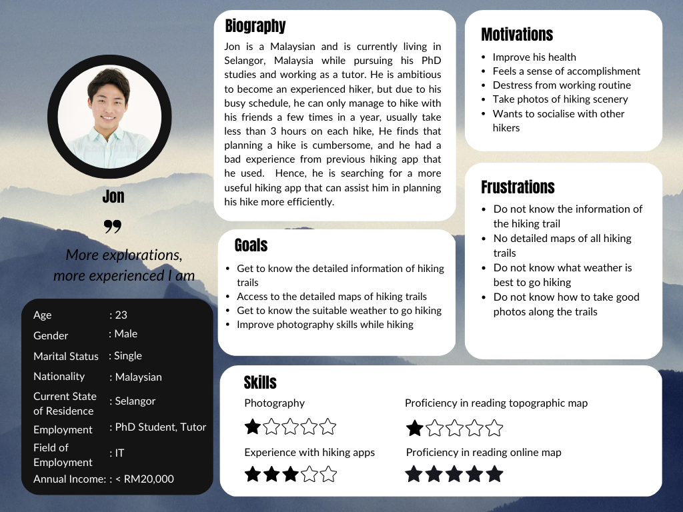

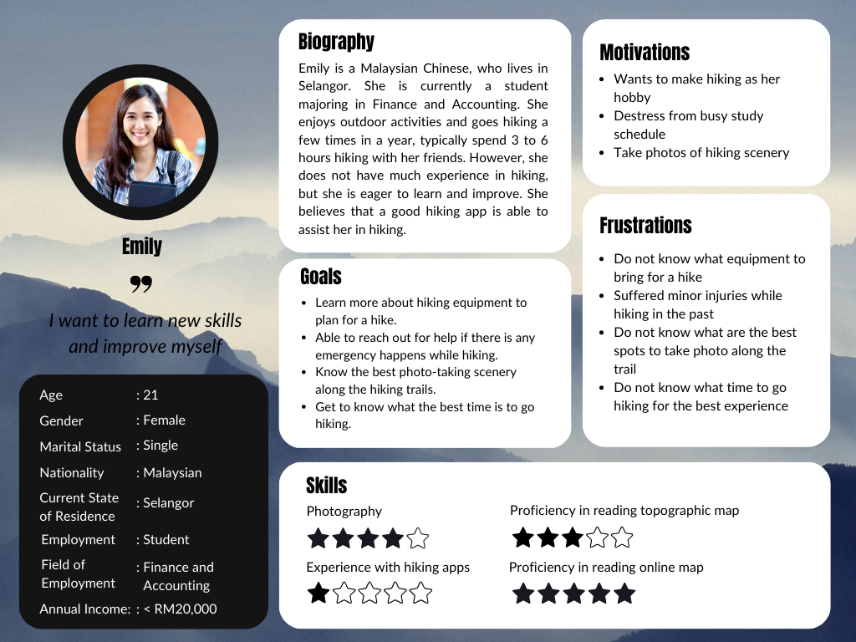

**User Stories**

| Priority | User Stories | Justification |
| --- | --- | --- |
| Must Have | * As Jon, I want to access detailed information about each hiking trail so that I can plan my hike more efficiently. * As Emily, I want to be able to view the hiking trails on a detailed map, so that I can navigate the trail easily and avoid getting lost during the hike. * As Emily, I want to learn more about hiking equipment to plan for a hike, so that I can have the necessary gear for a safe and comfortable hiking experience. * As Jon, I want to know the suitable weather to go hiking, so that I can plan my hike accordingly and avoid hiking during bad weather conditions. | Planning a hike can be time-consuming and challenging, especially for novice hikers or those with busy schedules. However, by providing comprehensive information about hiking trails in our app, hikers can easily find and filter trails based on their preferences. Given that most hikers are beginners, they may need an easy-to-read map to guide them along the trails.  Moreover, it's crucial for hikers to know what essentials they need to bring along for their hike. To save their time and effort, they need a complete list of equipment required for each hiking trail, so they don't have to search for these items online. Additionally, being aware of weather conditions before beginning a hike is essential for the hiker's safety and enjoyment. Hence, information on current and forecasted weather conditions is essential for planning a hike.  The features above are the key aspects that can fulfil most of the users’ needs, hence they must be implemented. |
| Should Have | * As Emily, I want to have access to safety information and emergency contacts for each hiking trail, so that I can easily reach out for any emergency help during my hike. | Hiking is undoubtedly an outdoor activity that involves potential risks, such as getting lost or experiencing injuries. It is crucial for hikers to have access to safety measures during the hike, and it raises the need to have emergency features in the hiking app. However, emergency contacts are not compulsory to have in the app, as some hikers are not comfortable to reach out to someone they do not know to ask for help, instead they may prefer to contact their known contacts. |
| Could Have |  |  |
| Won’t Have |  |  |

**Additional Requirements**

**A feature that allows users to get a list of hiking equipment they should bring for a hike.**

For beginner hikers, it can be challenging to know what equipment is necessary for a safe and comfortable hiking experience. Providing a feature that allows users to obtain a list of essential gear based on the trail difficulty level and weather conditions can help to ensure that they are properly prepared for their hike, as well as to enhance their user experience towards our app.

**A feature that would allow users to contact an offline emergency hotline**.

Safety is a significant concern among the hikers, especially for those who are new to hiking. By embedding the offline emergency hotline feature in the app, users can contact the emergency services even if they are in the area with poor or no network connection. In case of an accident or unexpected emergencies, they can use the feature that will automatically connect them to the nearest emergency service. The feature will also capture the user's GPS location, and share it with the emergency hotline operator. This can help the operator to locate the user and provide assistance as quickly as possible.

**Individual Analysis/Reflection**

After analysing the survey data, I have created two user personas, named Jon and Emily. These personas enable us to understand the motivations and frustrations of our users associated with their goals. By crafting user stories tailored to our personas, we can effectively explain how and why they would engage with our app. This approach helps us avoid the need to constantly refer to the raw survey data, allowing us to maintain a more streamlined and focused scope.

Jon is a 23-year-old male PhD student who is studying Information Technology, working as a part-time tutor during his spare time. He represents a group of enthusiastic but relatively inexperienced hikers who have used hiking apps and are now looking for a more efficient and useful hiking app to assist them in planning their hikes. I selected Jon's characteristics based on the largest group of users from our collected survey responses. The age group(18-35) is 88.4%, gender(male) is 58.9%, nationality(Malaysia) is 95.5%, ethnicity(Chinese) is 89.3%, and students who are studying Information Technology(IT) are 18.4%. Among the respondents from our survey who had experienced hiking apps and are keen to improve hiking skills, 68.75% of them are male. Jon likes hiking because he feels a sense of accomplishment after completing the trail. He is also ambitious to become an experienced hiker, however due to his busy schedule and the cumbersome process of planning a hike, he is restricted from going hiking frequently. He finds it difficult to get detailed information on all the hiking trails, such as the trail difficulty level, the trail location and distance, etc. For Jon, the most critical aspect of planning a hike is having access to detailed trail information. This can be seen from the data, as the majority of the survey respondents significantly ranked the importance of trail difficulty level, trail location, trail distance, trail amenities and trail reviews as either 3, 4 or 5 out of 5. Aside from that, Jon has experience in using hiking apps, and he is frustrated that the app does not provide detailed maps for all hiking trails, making it hard for him to navigate the trail as someone who is not familiar with the trail terrain. Furthermore, he prefers online maps instead of topographic maps due to his proficiency in reading the maps. The survey data shows that the majority of them, in which 80.4% of the targeted group ranked their capability to read a topographic map as either 1, 2 or 3 out of 5, whereas 94.6% of them ranked their capability to read an online map 3, 4, or 5 out of 5. To ensure his safety and the best possible hiking experience, he also wants to know the suitable weather conditions and avoid unfavourable weather. To cater to his needs, our app provides features for him to find the hiking trails based on his preferences, gain access to the detailed map, and get an updated weather forecast during his hike planning.

Emily, on the other hand, is a 21-year-old female undergraduate student who is studying Finance and Accounting. She represents a group of beginner hikers who do not have much experience in hiking, but are eager to learn and make hiking as a hobby. She enjoys outdoor activities and likes to take photos of nature along the hiking trails, which motivate her to go hiking. However, she only knows a little knowledge about hiking, for example she does not know what equipment to bring for a hike, and what is the best trail to choose according to her needs. Among the respondents, 45.2% of them respond that one of the challenges they face when planning a hike is uncertainty about what gear is necessary for the hike. This makes sense since beginner hikers may not have experience in knowing what essentials to bring or leave behind. Emily also experienced injuries in her hiking before, hence she wants to be able to reach out for help if there is an emergency happen during hiking. This is inspired from the analysis that 30.9% of the respondents suffered from injuries in their previous hiking experience. To make sure the safety of hikers is protected, our app provides a feature that allows hikers to contact an offline emergency hotline, allowing hikers to easily call for assistance in case of emergency.

# Appendix: Individual Tasks

## User Persona Templates

The user persona templates were created in Canva. 2 members will be using one of two templates created to maintain consistency throughout our report.

### Template 1

[Kai Yun & Caleb’s Template](https://www.canva.com/design/DAFdGBAllqc/mZGKOSdHN1h1CkRSZXrOjA/edit?utm_content=DAFdGBAllqc&utm_campaign=designshare&utm_medium=link2&utm_source=sharebutton)

### Template 2

[Zhen Xuan’s Template](https://docs.google.com/presentation/d/1sopUH1JNRZIJofNxxqxzp0JrY97_hu8k/edit?usp=sharing&ouid=103087182636940173097&rtpof=true&sd=true)

[Ansley’s Template](https://docs.google.com/presentation/d/1NQdN6lB_OuMfnPVOpNlgjF_XX_d_QeID/edit?usp=sharing&ouid=112376686858035969345&rtpof=true&sd=true)

## User Stories Technique

As a reference, user stories from each individual task were assigned priority using the MoSCoW prioritisation technique. A Kanban board as seen below was used for visualisation. The user stories are then put into tables as seen above for justification purposes.

Example:

